Assignment 1

A.HARITHA(192321147)

1) Write a program to calculate tax given the following conditions

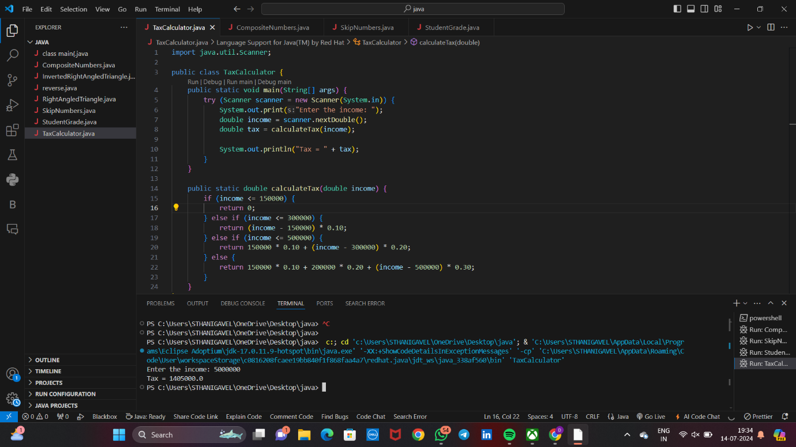

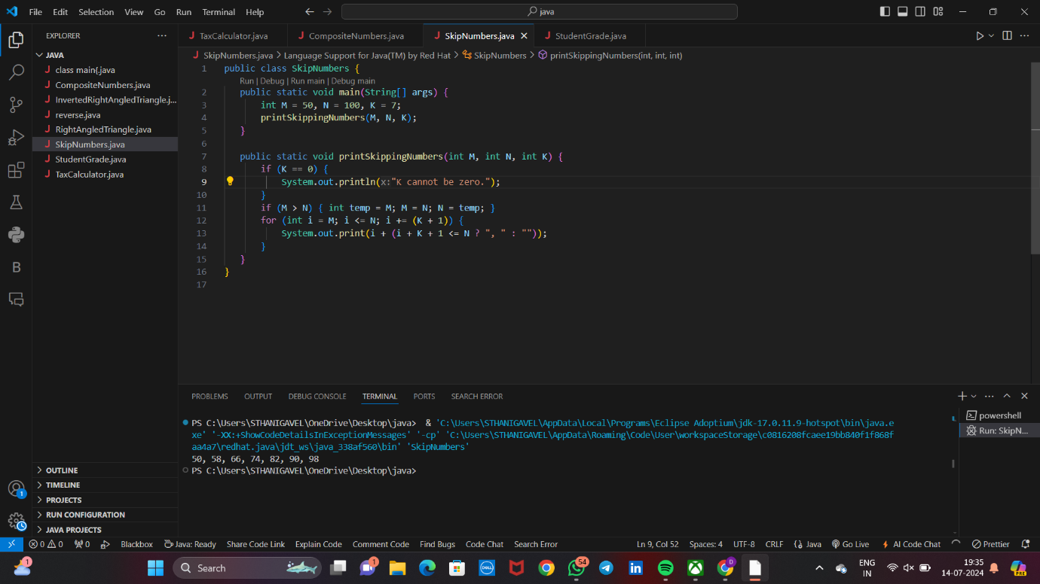2) Write a program to print the numbers from M to N by skipping K numbers in between?

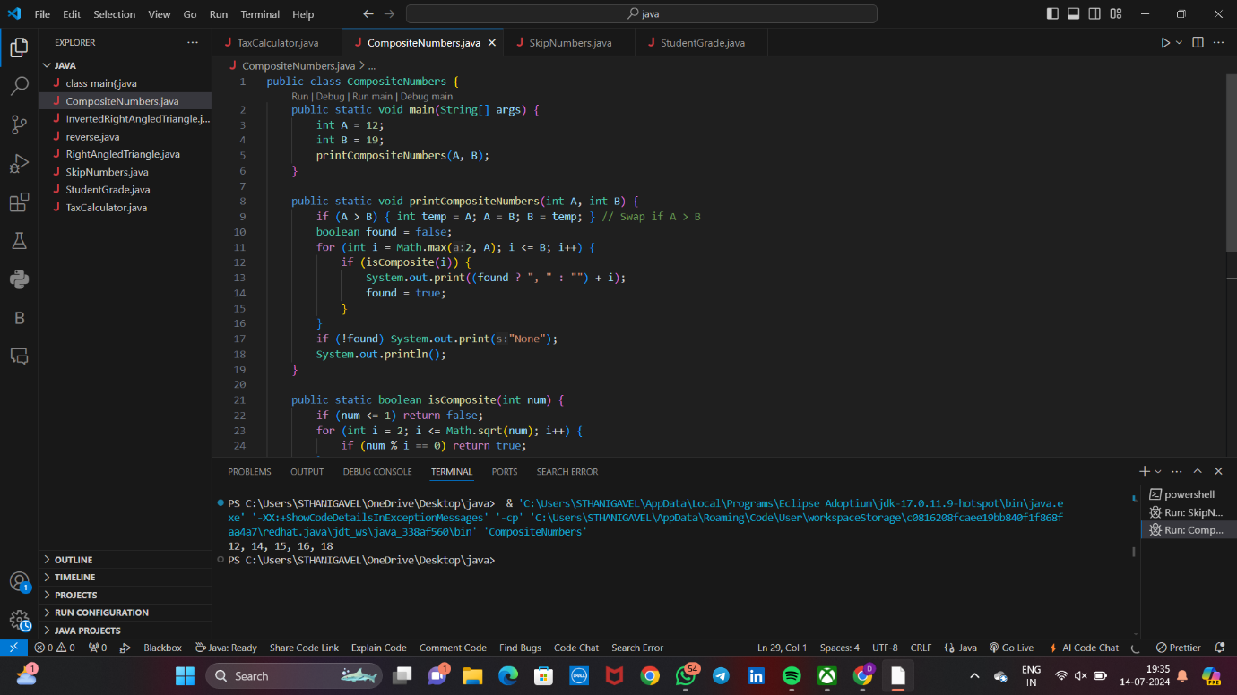3) Write a program to print all the composite numbers between a and b?

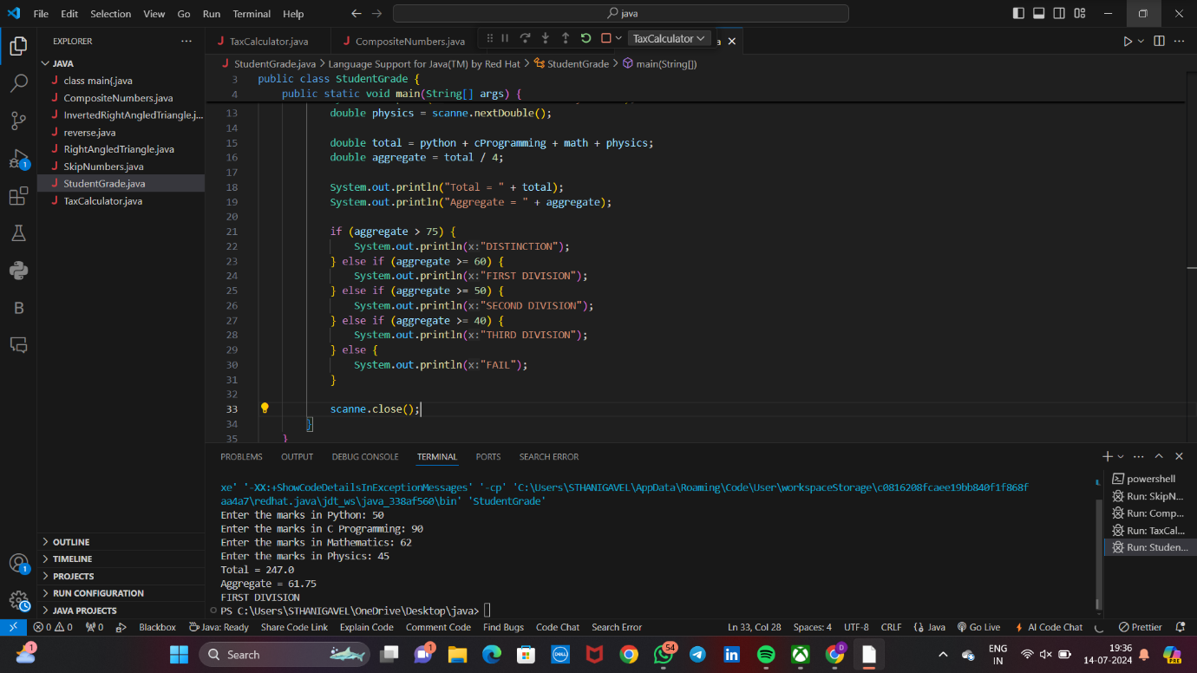4) Write a program to enter the marks of a student in four subjects. Then calculate the total and aggregate, display the grade obtained by the student. If the student scores an aggregate greater than 75%, then the grade is Distinction. If aggregate is 60>= and <75, then the grade is First Division. If aggregate is 50 >= and <60, then the grade is Second Division. If aggregate is 40>= and <50, then the grade is Third Division. Else the grade is Fail.